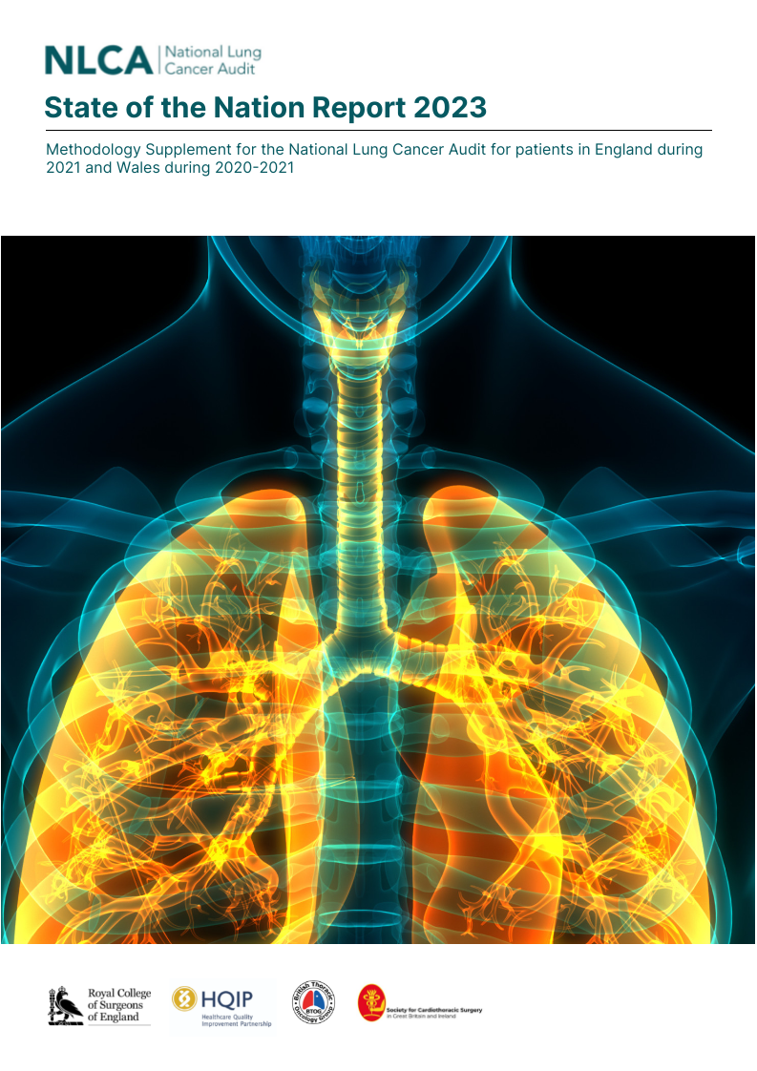

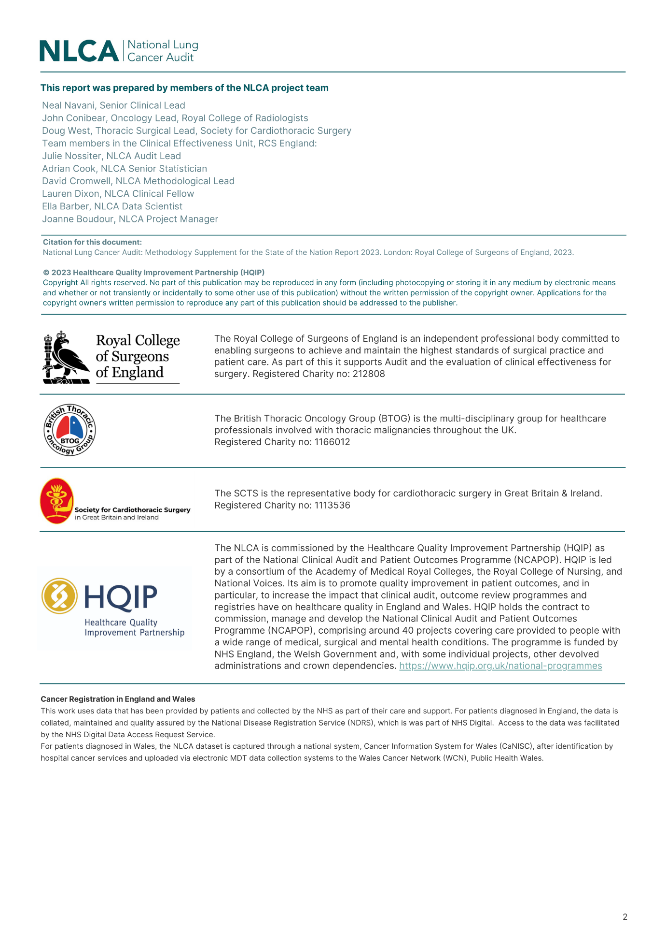

Contents

Abbreviations 4

List of Tables 5

Routine and cancer registration datasets 6

Patient inclusion 7

Data quality 7

Definition of variables 8

Performance status 9

Comorbidity status 9

Socioeconomic status 11

Disease staging 11

Treatment allocation 12

Performance indicators 13

Statistical analyses 20

Data visualisation 20

Analysis of the impact of COVID-19 21

References 21

Abbreviations

|  |  |
| --- | --- |
| Acronym | Description |
| CaNISC | Cancer Information System for Wales |
| CCI | Charlson Comorbidity Index |
| COSD | Cancer outcomes and services dataset |
| ECOG | Eastern Cooperative Oncology Group |
| HES | Hospital episode statistics |
| ICD-10 | International classification of diseases and related health problems,10th revision |
| IMD | Index of Multiple Deprivation |
| LCNS | Lung cancer nurse specialist |
| LSOA | Lower Super Output Areas |
| MDT | Multidisciplinary Team |
| NCDR | National Cancer Data Repository |
| NLCA | National lung cancer audit |
| NSCLC | Non-small cell lung cancer |
| ONS | Office for national statistics |
| PEDW | Patient Episode Database for Wales |
| PS | Performance status |
| RCRD | Rapid cancer registry data |
| RCS | Royal College of Surgeons of England |
| RTDS | Radiotherapy dataset |
| SACT | Systemic anti-cancer dataset |
| SCLC | Small cell lung cancer |
| WCN | Wales Cancer Network |

List of Tables

Table 1: Tumour morphology codes used to identify lung cancer type. 7

Table 2: Completeness of key data items for English patients diagnosed in 2021 (January-December) within the Rapid Cancer Registration Dataset 7

Table 3: Performance status scale, as defined by the Eastern Cooperative Oncology Group (ECOG) and published by Oken et al.1 8

Table 4: Pre-specified conditions included in the assignment of Charlson Comorbidity Index score and their associated codes 9

Table 5: Definition of overall stage for lung cancer patients without metastatic disease (M0) in TNM version 8. 10

Table 6: OPCS-4 procedure codes for surgical resection of the lung 12

Table 7: Definition of performance indicators used in the National Lung Cancer Audit State of the Nation Report. 13

Routine and cancer registration datasets

The National Lung Cancer Audit (NLCA) uses information from routine national health care datasets. These capture details on the diagnosis, management and treatment of every patient newly diagnosed with lung cancer in England and Wales.

In England, the NLCA receives information from the National Cancer Registration and Analysis Service (NCRAS). NCRAS collects patient-level data from all NHS acute providers on patients with cancer using a range of national data-feeds. This includes the Cancer Registration datasets and the Cancer Outcomes and Services Dataset (COSD). COSD data are submitted to the National Cancer Data Repository (NCDR) monthly via Multidisciplinary Team (MDT) electronic data collection systems. Clinical sign-off of data submitted to NCRAS is not mandated in England. The information held in the registration dataset is compiled from a number of sources.

For this annual report, the NLCA was provided with data from the Rapid Cancer Registration Dataset (RCRD). This dataset is compiled mainly from COSD records, and is made available more quickly than full NCRAS data. However, the speed of production means that the range of data items is limited and several standard Registration data items are unavailable. It also does not have complete coverage of all patients diagnosed with lung cancer in England during the reporting period. The RCRD was linked to other national health care datasets, including Hospital Episode Statistics (HES) admitted patient records, the National Radiotherapy Dataset (RTDS), the Systemic Anti-Cancer Therapy Dataset (SACT), and the Office for National Statistics (ONS) death register. The datasets were received by the NLCA in November 2022 and contained patient data submitted to NCRAS by English NHS trusts before July 2022.

For the 2023 NLCA State of the Nation report, English patients were allocated to NHS organisations based on the “place of diagnosis” recorded within the dataset. It was not possible to allocate patients to NHS organisations based on the “site first seen”, as done in previous reports, because the RCRD did not contain this data item. The algorithm used previously to determine “site first seen” could not be used with the data supplied for this report, and we encourage NHS trusts to ensure the COSD field “place first seen” is completed to enable this approach in future.

For patients treated in Wales, the NLCA was provided with a dataset by the Wales Cancer Network (WCN), Public Health Wales. Welsh cancer registration data is captured through a national system, Cancer Information System for Wales (CaNISC). Patients are identified by hospital cancer services who upload the information via electronic MDT data collection systems. Prior to the release of data to the NLCA by the WCN, each patient record is validated and signed off by a designated clinician. Patient records are signed off when all key data items have been completed. The Welsh registration records were linked to records from the Patient Episode Database for Wales (PEDW) which contains data describing all inpatient and day case activity undertaken within the NHS in Wales, alongside data for Welsh patients treated within English NHS trusts.

Patient inclusion

Patients were eligible for inclusion in the NLCA if ICD-10 code C34 was used to record a new diagnosis of primary lung cancer. Table 1 outlines tumour morphology codes used to identify the subtypes of lung cancer. Patients with small cell lung cancer (SCLC) or non-small-cell lung cancer (NSCLC) subtypes were included.

Patients with mesothelioma subtype, as documented through either ICD-10 codes (C450; C451; C457) or the tumour morphology codes in Table 1, were excluded. Patients were also excluded if their date of diagnosis was missing.

In this report, the analysis covered patients with these inclusion criteria who were diagnosed in the calendar years 2019, 2020 and 2021.

Table 1: Tumour morphology codes used to identify lung cancer type.

|  |  |
| --- | --- |
| Lung cancer type | Tumour morphology code |
| Included cases |  |
| Small cell lung cancer | 8041/3,8042/3,8043/3,8045/3 |
| Carcinoid | 8240/3 |
| Non-small-cell lung cancer | M8070/3, 8140/3, any other type of epithelial lung cancer |
| Excluded cases |  |
| Mesothelioma | 9050/3,9051/3,9052/3,9053/3 |

Data quality

As an overview of data quality in the English RCRD, Table 2 describes the completeness of six key data items (TMN stage, performance status, morphology, basis of diagnosis, access to lung cancer nurse specialist and smoking status).  These data items, which are based on the NHS organisation where the patient was diagnosed, are essential to be able to define patient subgroups and define the NLCA performance indicators.

Completeness of these key data items within the English RCRD are reported at the level of NHS trust and Cancer Alliance in the data viewer, which can be found on the NLCA website. However, as not all patients had a trust of diagnosis in the RCRD data, the total number of patients in the Cancer Alliance and NHS trust rows is less than the national figure.

Table 2: Completeness of key data items for English patients diagnosed in 2021 (January-December) within the Rapid Cancer Registration Dataset

|  |  |  |  |
| --- | --- | --- | --- |
| Data item | Completeness | Target level | No. of NHS trusts  above target (n=126) |
| TNM stage | 86.0 | 90% | 60 |
| Performance Status (PS) | 82.7 | 90% | 54 |
| Morphology | 64.8 | 75% | 30 |
| Basis of diagnosis | 90.4 | 90% | 97 |
| Access to lung cancer clinical nurse specialist (LCNS) | 59.3 | 90% | 0 |
| Smoking status | 49.3 | 90% | 12 |

The data on Welsh patients came from the standard cancer registration dataset collected through the Cancer Network Information System Cymru (CaNISC). The figures on completeness are therefore not directly comparable to the English data, which is derived from the [Rapid Cancer Registration Dataset](https://pubmed.ncbi.nlm.nih.gov/36180356/).

The completeness of the Welsh data was excellent for each year. In 2021, the levels of completeness for the 2,244 patients diagnosed were: 100% for basis of diagnosis, 100% for tumour morphology, 98.1% for disease stage, and 97.0% for performance status. 97.5% of records had data on whether a lung cancer clinical nurse specialist was present at diagnosis. Data was not provided on ethnicity or smoking status.

Definition of variables

The aim of the NLCA, commissioned by the Healthcare Quality Improvement Partnership, is to evaluate the care received by patients diagnosed with lung cancer in NHS hospitals within England and Wales.

The NLCA considers the following possible reasons for variation in lung cancer care:

1. Differences in patient frailty and prevalence of comorbidities that may contraindicate surgery, systemic anti-cancer therapy (SACT) or radiotherapy.
2. Differences in the nature and extent of disease, notably the distinct tumour subtypes of non-small-cell lung cancer (NSCLC) and small-cell lung cancer (SCLC) given their distinct patterns of care and prognosis.
3. Variations in the uptake of and access to new technologies and treatment techniques e.g., stereotactic radiotherapy, hospitals participating in clinical trials.

The audit uses a set of performance indicators as the basis of this evaluation. This section describes the variables used in the calculation of the performance indicators.

### Performance status

Performance status is used by clinicians to classify a patient’s functional impairment. It is used to group patients when comparing treatment effectiveness and assessing prognosis to help remove differences in patient case-mix. This is important for the audit because the distribution of patient performance status can vary between organisations, and case mix adjustment is required for some indicators. Details of the indicators for which case mix adjustment was performed can be found in Table 7.

Various scoring systems exist for evaluating performance status. The Eastern Cooperative Oncology Group (ECOG) system was widely used by cancer services and is collected by the cancer registration services. Table *3* outlines the ECOG performance status scale. Clinicians use standard criteria to assign patient’s a performance status score, and each category describes the extent to which a person can perform activities of daily living.

Table 3: Performance status scale, as defined by the Eastern Cooperative Oncology Group (ECOG) and published by Oken *et al*.1

|  |  |
| --- | --- |
| Grade | Description |
| 0 | Fully active, able to carry on all pre-disease performance without restriction |
| 1 | Restricted in physically strenuous activity but ambulatory and able to carry out work of a light or sedentary nature, e.g., light housework, office work |
| 2 | Ambulatory and capable of all self-care but unable to carry out any work activities. Up and about more than 50% of waking hours |
| 3 | Capable of only limited self-care, confined to bed or chair more than 50% of waking hours |
| 4 | Completely disabled. Cannot carry on any self-care. Totally confined to bed or chair |
| 5 | Dead |

### Comorbidity status

The presence of comorbidities is not captured within a single data item by the national registration services. The NLCA team used the Royal College of Surgeons of England (RCS) modified Charlson Comorbidity Index (CCI) to measure the comorbidity burden of patients (see Armitage *et al*.2 for details).

The CCI is a commonly used scoring system for medical comorbidities. It consists of a grouped score that is calculated based on the absence (0) or presence (≥1) of the pre-specified medical conditions listed in Table 4. The CCI was calculated using information on secondary diagnoses (ICD-10 codes) in the hospital admission data (HES/PEDW) recorded within the 12-month period prior to a patient’s diagnosis.

The CCI score was used to perform risk-adjustment for certain performance indicators. Indicators for which risk adjustment was performed are outlined in Table 7.

Table 4: Pre-specified conditions included in the assignment of Charlson Comorbidity Index score and their associated codes

|  |  |
| --- | --- |
| Medical condition | ICD-10 diagnostic code(s) |
| AIDS/HIV infection | B20; B21; B22; B23; B24 |
| Cerebrovascular disease | G45; G46; I6 |
| Chronic pulmonary disease | Chronic: I26; I27; J40; J41; J42; J43; J44; J45; J47; J60; J61; J62; J63; J64; J65; J66; J67; J684; J701; J703  Acute: J46** |
| Congestive cardiac failure | I11; I13; I42; I43; I50; I255; I517 |
| Dementia | A810; F00; F01; F02; F03; F051; G30; G31 |
| Diabetes mellitus | E10; E11; E12; E13; E14 |
| Hemiplegia or paraplegia | G114; G81; G82; G83 |
| Liver disease | B18; I85; I864; I982; K70; K71; K721; K729; K76; R162; Z944 |
| Metastatic solid tumour | C77; C78; C79 |
| Myocardial infarction (MI) | Acute MI: I21**; I22**; I23**  History of MI: I252 |
| Peripheral vascular disease | I70; I71; I72; I73; I770; I771; K551; K558; K559; R02; Z958; Z959 |
| Renal disease (RD) | Chronic: I12; I13; N01; N03; N05; N07; N08; N18; N25; Z49; Z940; Z992  Acute: N171**; N172**; N19** |
| Rheumatological disease | M05; M06; M09; M120; M315; M32; M33; M34; M35; M36 |

** Code associated with an acute episode, only counted in admissions prior to the index admission

### Socioeconomic status

In England and Wales, small regional areas are assigned a measure of social deprivation, called the Index of Multiple Deprivation (IMD). The Index is constructed from various individual deprivation scales and a score is derived for each area (Lower Super Output Areas [LSOA], which contain approximately 1500 people) in England and Wales. Separate IMD scores are derived from England and Wales.

In the analyses, patients were categorised into one of five socioeconomic groups (1=least deprived; 5=most deprived) based on the IMD score of the area in which they lived. The five categories were based on the quintiles of the ranked IMD scores.

### Disease staging

Primary lung cancer is classified into various types, according to the types of cells from which the cancer originates.3

NSCLC is the most common type of primary lung cancer and accounts for between 80% to 85% of cases.3 SCLC is a less common type of primary lung cancer and spreads faster than NSCLC.3 Table 1 describes the tumour morphology codes used to differentiate these subtypes of lung cancer.

The extent to which a tumour has grown and spread to the lymphatic system and other organs is denoted by the cancer stage. This information is one of the important factors that patients and clinicians consider when making treatment decisions.

Clinicians typically use the TNM staging system to describe the extent of an individual’s lung cancer.4 The staging system captures characteristics of the tumour, lymph nodes, and whether there are any metastases:

* T describes the size of the tumour, categorising it into: T1{mi, a,b,c}, T2{a,b}, T3, T4
* N describes the extent to which cancer cells are present in nearby lymph nodes, categorising it into N0, N1, N2 and N3.
* M describes whether the cancer has spread to a different part of the body, with M0 indicating no spread and M1a, M1b, M1c indicating the extent of metastases.

The individual T, N and M stages are combined to create an overall stage. Stages 1-3 describe localised disease (M0); Table 5 describes how the T and N categories combine to form the overall score for TNM version 8. Patients with metastatic lung cancer (M1a, b, c) are described as Stage 4 regardless of the T and N stages.

Table 5: Definition of overall stage for lung cancer patients without metastatic disease (M0) in TNM version 8.

|  |  |  |  |  |  |
| --- | --- | --- | --- | --- | --- |
| Stage | T | N | Stage | T | N |
| IA1 | T1mi, T1a | N0 | IIIA | T1a,b,c | N2 |
| IA2 | T1b | N0 |  | T2a,b | N2 |
| IA3 | T1c | N0 |  | T3 | N1 |
| IB | T2a | N0 |  | T4 | N0, N1 |
| IIA | T2b | N0 | IIIB | T1a,b,c | N3 |
| IIB | T1a,b,c | N1 |  | T2a,b | N3 |
|  | T2a,b | N1 |  | T3, T4 | N2 |
|  | T3 | N0 | IIIC | T3, T4 | N3 |

To stage SCLC, clinicians sometimes use a simpler system which differentiates between limited or extensive disease.5 In these cases, data for the T, N and M stages are not available.

* **Limited disease** SCLC is described as limited if the cancer is contained in a single area on one side of the chest. Limited disease may be in: (i) only one lung, or (ii) involve only nearby lymph nodes (for example, in the centre of the chest)
* **Extensive disease.** Extensive disease means that the cancer has spread beyond the lung and cancer cells have been detected within the chest or other parts of the body.

The distribution of cancer stage among the patients treated at organisations can vary greatly. Disease stage was included in the risk adjustment model when it was necessary for an indicator value to account for this. Details of the indicators for which case mix adjustment was performed can be found in Table 7.

### Treatment allocation

Patients were considered to have undergone treatment for lung cancer if they were identified as having received chemotherapy, radiotherapy or undergone surgery. The various therapies received by patients treated in English NHS trusts required combining information across a range of datasets with the records in the Rapid Cancer Registration Dataset, and were identified as follows:

* **Chemotherapy:** The SACT dataset was used to identify patients who received chemotherapy. Patient records in SACT were excluded where the analysis group was listed as: enzalutamide, abiraterone, zoledronic acid or trial unspecified.
* **Radiotherapy:** The RTDS dataset was used to identify patients who received teletherapy and/or brachytherapy. A patient was coded as receiving curative radiotherapy if a patient record had an ICD-10 diagnosis code recorded as C34, the anatomical site recorded as OPCS-4 code Z246 (to exclude metastases), and radiotherapy intent to be curative.
* **Surgery to remove part of the lung:** Surgical resection procedures were included if they appeared in a patients record one month before diagnosis date or up to six months after. Records in the HES dataset were used to determine if a patient had undergone surgery, with the analysis identifying eligible operations using the OPCS-4 procedure codes listed in Table 6.

For Welsh patients, the analysis of modes of therapy was restricted to the details in the CaNISC cancer registration dataset. Information on the receipt of chemotherapy was described in terms of the date that chemotherapy started, the treatment intent and the organisation at which the chemotherapy was delivered. Similar fields contained information on whether radiotherapy was delivered. Whether a patient had undergone a surgical resection was derived from procedure data items, which gave the date of surgery, a description of the procedure and the OPCS-4 procedure code. Patients were flagged as having surgery if the OPCS-4 procedure code matched those listed in Table 6.

Table 6: OPCS-4 procedure codes for surgical resection of the lung

|  |  |
| --- | --- |
| Surgical procedure | Procedure code |
| Pneumonectomy | E541 |
| Lobectomy | E542; E543 |
| Sleeve/wedge | E544; E545; E548; E549; E552; E554; E559 |
| Other | E391; E398; E399; E461; E463; E468; E558; T013; T018 |

### Performance indicators

The NLCA uses key performance indicators to monitor progress against the audit’s healthcare improvement goals. These indicators align to the recommendations in the [NICE guideline](https://www.nice.org.uk/guidance/ng122/resources/lung-cancer-diagnosis-and-management-pdf-66141655525573) (NG122) and the [NICE quality standards](https://www.nice.org.uk/guidance/qs17) (QS17).

Table 7 describes the 11 performance indicators within the NLCA annual report, provides details of the data variables used in their calculation and outlines where risk adjustment has been performed.

Some indicators differentiate between patients with NSCLC and SCLC. This is because these two subtypes have distinct patterns of care. Some indicators are further focused on subgroups of patients as defined by the stage of the disease and their general physical health. Both factors are important determinants of whether specific therapies are suitable for patients. For example, patients with severity of comorbidities or who are frail (e.g., have a poor performance status) are unlikely to benefit from systemic anti-cancer therapy.

As the distribution of cancer stage and patient performance status can vary greatly between organisations, a case mix adjustment was performed when calculating some of the indicators.

Table 7: Definition of performance indicators used in the National Lung Cancer Audit State of the Nation Report.

| Indicator | Description |
| --- | --- |
| WORKSTREAM 1: DIAGNOSIS | |
| Proportion of patients with pathological diagnosis (Stage I-II, PS 0–1) | This process indicator provides information on early diagnosis which supports a key ambition of the [NHS Long term Plan](https://www.longtermplan.nhs.uk/wp-content/uploads/2019/08/nhs-long-term-plan-version-1.2.pdf). It is also relates to NICE Quality Standard [statement 5](https://www.nice.org.uk/guidance/qs17/chapter/Quality-statement-5-Treatment-with-curative-intent#quality-measures-5) and [statement 6](https://www.nice.org.uk/guidance/qs17/chapter/Quality-statement-6-Tissue-sampling#quality-measures-6).  To calculate this indicator, a numerator is divided by a denominator.  **NUMERATOR:** Number of patients with a valid pathological diagnosis  **DENOMINATOR**: All patients with stage I-II lung cancer and PS 0-1 (excludes mesothelioma).  Risk-adjusted: no |
| Median time from diagnosis to treatment | This process indicator provides information on compliance with the [National Optimal Lung Cancer Pathway](https://www.roycastle.org/app/uploads/2019/07/Lung_Cancer_Implementation_Guide_August_2017.pdf), which sets timeframes for each stage of the care pathway, enabling treatment for patients to start within 49 days of lung cancer being suspected.  Risk-adjusted: no |
| Proportion of patients diagnosed with lung cancer via emergency presentation | This process indicator provides information on the proportion of patients diagnosed after an emergency presentation. This indicator complements the work of the [NHS England’s Lung Health Checks](https://www.england.nhs.uk/contact-us/privacy-notice/how-we-use-your-information/our-services/evaluation-of-the-targeted-lung-health-check-programme/) initiative, part of the [NHS Long Term Plan](https://www.longtermplan.nhs.uk/wp-content/uploads/2019/08/nhs-long-term-plan-version-1.2.pdf) to improve early diagnosis and survival for those diagnosed with cancer. It also relates to NICE 2019 Quality Standards: increasing the proportion of patients encouraged to seek medical advice if experiencing symptoms ([statement 1](https://www.nice.org.uk/guidance/qs17/chapter/Quality-statement-1-Public-awareness)).  To calculate this indicator, a numerator is divided by a denominator.  **NUMERATOR:** Number of patients who were diagnosed via an emergency route.  **DENOMINATOR**: All patients with a new diagnosis of lung cancer (excludes mesothelioma).  **Risk-adjusted:** age, sex (Wales only), comorbidity, stage, performance status, tumour type, audit year (Wales only) |
| WORKSTREAM 2: TREATMENT PLANNING AND PATTERNS OF CARE | |
| Proportion of patients with NSCLC who had curative treatment (Stage I-II, PS 0–2) | This process indicator provides information on the proportion of patients who receive treatment with curative intent. This reflects [NICE guideline](https://www.nice.org.uk/guidance/ng122/resources/lung-cancer-diagnosis-and-management-pdf-66141655525573) recommendations for patients with NSCLC undergoing resection surgery and adjuvant therapy. It is also related to NICE 2019 Quality Standards: increasing the proportion of patients encouraged to seek medical advice if experiencing symptoms ([statement 1](https://www.nice.org.uk/guidance/qs17/chapter/Quality-statement-1-Public-awareness)) and ensuring that patients suitable for curative treatment have their stage and lung function established ([statement 4](https://www.nice.org.uk/guidance/qs17/chapter/Quality-statement-4-Investigations) and [statement 5](https://www.nice.org.uk/guidance/qs17/chapter/Quality-statement-5-Treatment-with-curative-intent))  To calculate this indicator, a numerator is divided by a denominator.  **NUMERATOR:** Number of patients who receive curative resection surgery or radical radiotherapy  **DENOMINATOR**: All patients with stage I-II NSCLC and PS 0-2.  **Risk-adjusted:** age, sex (Wales only), comorbidity, stage, performance status, tumour type, audit-year (Wales only) |
| Proportion of patients with NSCLC who had curative treatment (Stage IIIA, PS 0–2) | This process indicator provides information on the proportion of patients who receive treatment with curative intent. This will reflect [NICE guideline](https://www.nice.org.uk/guidance/ng122/resources/lung-cancer-diagnosis-and-management-pdf-66141655525573) recommendations for patients with NSCLC undergoing resection surgery and adjuvant therapy. It is also related to two NICE 2019 Quality Standards: increasing the proportion of patients encouraged to seek medical advice if experiencing symptoms ([statement 1](https://www.nice.org.uk/guidance/qs17/chapter/Quality-statement-1-Public-awareness)) and ensuring that patients suitable for curative treatment have their stage and lung function established ([statement 4](https://www.nice.org.uk/guidance/qs17/chapter/Quality-statement-4-Investigations))  To calculate this indicator, a numerator is divided by a denominator.  **NUMERATOR:** Number of patients who receive curative resection surgery or radical radiotherapy  **DENOMINATOR**: All patients with stage IIIA NSCLC and PS 0–2  **Risk-adjusted:** age, sex (Wales only), comorbidity, performance status, tumour type, audit-year (Wales only) |
| Proportion of patients with NSCLC undergoing surgery | This process indicator provides information on the proportion of NSCLC patients undergoing surgery. This reflects [NICE guideline](https://www.nice.org.uk/guidance/ng122/resources/lung-cancer-diagnosis-and-management-pdf-66141655525573) recommendations for patients with NSCLC who are well enough and for whom treatment with curative intent is suitable to be offered lobectomy. It is also related to NICE 2019 Quality Standards [statement 5](https://www.nice.org.uk/guidance/qs17/chapter/Quality-statement-5-Treatment-with-curative-intent): treatment with curative intent.  To calculate this indicator, a numerator is divided by a denominator.  **NUMERATOR:** Number of patients who had resection surgery.  **DENOMINATOR**: All patients with NSCLC  **Risk-adjusted:** age, sex (Wales only), comorbidity, stage, performance status, tumour type, audit-year (Wales only) |
| Proportion of patients with SCLC receiving chemotherapy | This process indicator provides information on the proportion of SCLC patients receiving chemotherapy. This reflects [NICE guideline](https://www.nice.org.uk/guidance/ng122/resources/lung-cancer-diagnosis-and-management-pdf-66141655525573) recommendations to offer platinum-based combination chemotherapy to people with extensive stage disease SCLC if they are fit enough.  To calculate this indicator, a numerator is divided by a denominator.  **NUMERATOR:** Number of patients with a recorded date of chemotherapy  **DENOMINATOR**: All patients with pathologically confirmed SCLC  **Risk-adjusted:** age, sex (Wales only), comorbidity, stage, performance status, audit-year (Wales only) |
| Proportion of patients with NSCLC (IIIB–IVB, PS 0–1) who had systemic anticancer therapy | This process indicator provides information on the proportion of patients who receive treatment who had systemic anticancer therapy. This reflects [NICE guideline](https://www.nice.org.uk/guidance/ng122/resources/lung-cancer-diagnosis-and-management-pdf-66141655525573) recommendations for patients with stage IIIB or IV NSCLC and eligible PS to be offered systemic therapy.  To calculate this indicator, a numerator is divided by a denominator.  **NUMERATOR:** Number of patients who receive systemic anticancer therapy  **DENOMINATOR**: All patients with stage IIIB–IVB NSCLC and PS 0–1  **Risk-adjusted:** age, sex (Wales only), comorbidity, stage, performance status, tumour type, audit-year (Wales only) |
| Proportion of patients seen by LCNS | This process indicator provides information on the proportion of patients who are assessed by a lung cancer nurse specialist (LCNS) and reflects NICE 2019 Quality Standard [statement 3](https://www.nice.org.uk/guidance/qs17/chapter/Quality-statement-3-Lung-cancer-clinical-nurse-specialist).  To calculate this indicator, a numerator is divided by a denominator.  **NUMERATOR:** Number of patients with a record of contact with a LCNS (COSD CR2050 codes Y1, Y3, Y4)  **DENOMINATOR**: All patients diagnosed within the audit period (excludes mesothelioma)  Risk-adjusted: no |
| WORKSTREAM 3: OUTCOMES | |
| Median survival | This outcome indicator describes the length of time (days) for which half of all diagnosed patients survive. This will monitor medium-term survival rates for patients with lung cancer and monitor progress towards the [UK Lung Cancer Coalition](https://www.uklcc.org.uk/) goal of raising 5-year survival to 25% by 2025.  Risk-adjusted: no |
| One year survival | This outcome indicator describes the number of diagnosed patients who are still alive one year after their diagnosis. This will monitor medium-term survival rates for patients with lung cancer and monitor progress towards the [UK Lung Cancer Coalition](https://www.uklcc.org.uk/) goal of raising 5-year survival to 25% by 2025.  **Risk-adjusted:** age, sex (Wales only), comorbidity, stage, performance status, tumour type |

Statistical analyses

All statistical analyses were performed using STATA version 17.0.

In the Annual Report, descriptive statistics summarise categorical data items as percentages (%). The denominator of these percentages is, in most cases, the number of patients for whom the value of the data item was not missing. Results are grouped by NHS trust (England) or Health Board (for Wales).

Results for centres with indicator denominator values less than 10 were suppressed.

Multivariable logistic regression was performed to risk adjust the performance indicators whose value was expressed as a percentage. The regression model was used to estimate the probability of a patient having an event, and to produce the expected number of events at an organisation, the individual probabilities of the patients at that organisation were summed. The adjusted indicator value for an organisation was then calculated as: the observed number of events divided by the expected number, multiplied by the overall national average.

Data variables used in risk adjustment included:

* Age at diagnosis (years)
* Sex (Wales only; unavailable for England)
* Number of Charlson comorbidities: 0, 1, 2, 3+
* Disease stage
* Performance status
* Tumour type: SCLC, NSLC (known histology), NSLC (unknown histology)
* Audit year (Wales only)

Details of risk adjustment performed for each indicator are provided in Table 7.

Data visualisation

Funnel plots are used to graphically display variation and enable comparisons between NHS Trusts and Health Boards.6 The plots show the indicator value for each NHS organisation on the vertical axis and the total number of patients used to calculate the indicator value on the horizontal axis. The ‘target’ is specified as the average rate across all Trusts/Health Boards/specialist MDT.

The funnel plots generated for the performance indicators use control limits defining the range within which an indicator value might be expected to fall if it only differed from the target value because of random variation. Differences corresponding to two standard deviations (inner limits) and three standard deviations (outer limits) from the national average. The control limits become progressively narrower as the volume of data on which an indicator value is based becomes larger. This reflects the increased levels of uncertainty around an organisation’s result when the organisation treated fewer patients.

Funnel plots for one year survival for England and Wales are displayed in the State of the Nation Report. Funnel plots for other indicators can be found in the data viewer.

Due to the unusual circumstances underpinning data collection and collation, resulting in the unavailability of standard cancer registration data, the NLCA has not carried out a formal outlier process in this report. Individual provider results can still be accessed and assessed on our website.

Analysis of the impact of COVID-19

A separate report by Conibear *et al*.7 details changes made to NLCA data collection, associated analyses and subsequent outcomes for lung cancer patients within the NHS during the COVID-19 pandemic.

References

1. Oken, M. M. *et al.* Toxicity and response criteria of the Eastern Cooperative Oncology Group. *Am J Clin Oncol* **5**, 649–55 (1982).

2. Armitage, J. N., van der Meulen, J. H. & Royal College of Surgeons Co-morbidity Consensus Group. Identifying co-morbidity in surgical patients using administrative data with the Royal College of Surgeons Charlson Score. *Br J Surg* **97**, 772–81 (2010).

3. UK National Health Service (NHS). Lung cancer overview. https://www.nhs.uk/conditions/lung-cancer/ (2022).

4. Rami-Porta, R. *et al.* Lung cancer staging: a concise update. *Eur Respir J* **51**, (2018).

5. Rudin, C. M., Brambilla, E., Faivre-Finn, C. & Sage, J. Small-cell lung cancer. *Nat Rev Dis Primers* **7**, 3 (2021).

6. Spiegelhalter, D. J. Funnel plots for comparing institutional performance. *Stat Med* **24**, 1185–202 (2005).

7. Conibear, J. *et al.* The National Lung Cancer Audit: The Impact of COVID-19. *Clin Oncol (R Coll Radiol)* **34**, 701–707 (2022).